JavaScript Assignment

1.Accept two numbers as inputs from the user

Perform the following operations and logs the results:

* + - Addition
    - Substraction
    - Multiplication
    - Division
    - Modulus

Ans:

function Arithmeticop() {

    let num1 = Number(prompt("Enter the first number:"));

    let num2 = Number(prompt("Enter the second number:"));

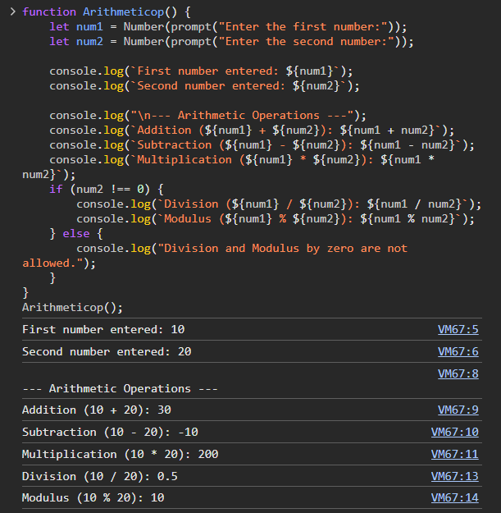    console.log(`First number entered: ${num1}`);

    console.log(`Second number entered: ${num2}`);

    console.log("\n--- Arithmetic Operations ---");

    console.log(`Addition (${num1} + ${num2}): ${num1 + num2}`);

    console.log(`Subtraction (${num1} - ${num2}): ${num1 - num2}`);

    console.log(`Multiplication (${num1} \* ${num2}): ${num1 \* num2}`);

    if (num2 !== 0) {

        console.log(`Division (${num1} / ${num2}): ${num1 / num2}`);

        console.log(`Modulus (${num1} % ${num2}): ${num1 % num2}`);

    } else {

        console.log("Division and Modulus by zero are not allowed.");

    }

}

Arithmeticop();

2.Uses comparison operators to check:

* If the first number is greater than second .
* If the first number is less than second
* If both numbers are equal

Ans:

let num1= Number(prompt("Enter the first number for comparison:"));

let num2 = Number(prompt("Enter the second number for comparison:"));

if (num1 > num2) {

        console.log(`${num1} is greater than ${num2}. (True)`);

    } else {

        console.log(`${num1} is NOT greater than ${num2}. (False)`);

    }

    if (num1 < num2) {

        console.log(`${num1} is less than ${num2}. (True)`);

    } else {

        console.log(`${num1} is NOT less than ${num2}. (False)`);

    }

    if (num1 === num2) {

        console.log(`${num1} is strictly equal to ${num2}. (True)`);

    } else {

        console.log(`${num1} is NOT strictly equal to ${num2}. (False)`);

    }

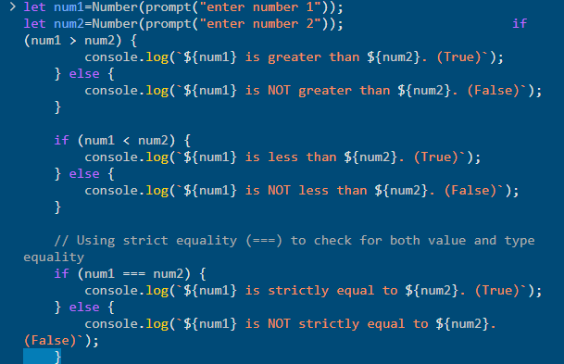

3.Declare a variable x and assign it an initial value of 10.

Perform the following operations using assignment operator and log the results after each step:

* Add 5 to x.
* Multiply x by 3.
* Substract 10 from x
* Divide x by 2
* Find the modulus of x with 3

Ans:

    let x = 10;

    console.log(`Initial value of x: ${x}`);

    x += 5;

    console.log(`After adding 5: x = ${x}`);

    x \*= 3;

    console.log(`After multiplying by 3: x = ${x}`);

    x -= 10;

    console.log(`After subtracting 10: x = ${x}`);

    x /= 2;

    console.log(`After dividing by 2: x = ${x}`);

    x %= 3;

    console.log(`After finding modulus with 3: x = ${x}`);

4. write the program that:

1. Accepts the number from the user
2. Uses the modulus operator to check if the number even or odd
3. logs the result.

Ans:

  let x= Number(prompt("Enter a number :"));

    if(x%2==0){

        console.log(`${x} is an even number.`);

    }else{

        console.log(`${x} is an odd number.`);

    }

5. Write a program that calculates the sum of the digits of a number using do …while loop

Ans:

let sum=0;

let num=123;

while(num>0){

    let digit=num%10;

    sum+=digit;

    num=Math.floor(num/10);

}

6.write a program that calculates the factorial of a number using while loop.

Ans:

let num=5;

let factorial = 1;

while (num > 0) {

    factorial \*= num;

    num--;

}

console.log(`The factorial is: ${factorial}`);

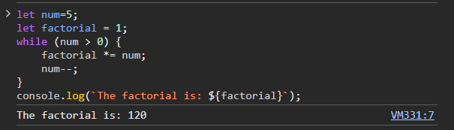7.Count the number of occurrences of a specific character in string

Ans:

let string = "Hello, World!";

let charToSearch = "l";

let count = 0;

for (let i = 0; i < string.length; i++) {

    if (string[i] === charToSearch) {

        count++;

    }}

console.log(`The character '${charToSearch}' appears ${count} times in the string.`); 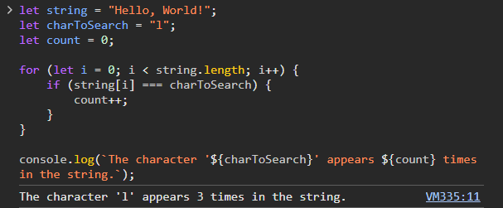

8.Write a function to generate a multiplication table for a number.

Ans:

function table() {

    let num = Number(prompt("Enter a number to generate its multiplication table:"));

    console.log(`Multiplication Table for ${num}:`);

    for (let i = 1; i <= 10; i++) {

        console.log(`${num} x ${i} = ${num \* i}`);

    }

}

table();

9.Create a function to calculate the Fibonacci Series up to n terms.

Ans:

function fibonnaci() {

    let n = Number(prompt("Enter the number of terms in the Fibonacci sequence:"));

    let a = 0, b = 1, c;

    console.log(`Fibonacci sequence up to ${n} terms:`);

    for (let i = 1; i <= n; i++) {

        console.log(a);

        c = a + b;

        a = b;

        b = c;

    }

}

fibonnaci();

10.Write a program to find the frequency of each element in an array.

Ans:

let arr = [1, 2, 3, 1, 5];

let frequency = {};

let finding = Number(prompt("Enter a number to find its frequency in the array:"));

for (let i = 0; i < arr.length; i++) {

    let num = arr[i];

    if (frequency[num]) {

        frequency[num]++;

    } else {

        frequency[num] = 1;

    }

}

if (frequency[finding]) {

    console.log(`The number ${finding} appears ${frequency[finding]} times in the array.`);

} else {

    console.log(`The number ${finding} does not appear in the array.`);

}

